Work Task2 for the Ph.D. Position in GenAI @ BTH

Prepared By: Kanchana Weerasinghe

**1. Objective**

The objective of this project is to generate synthetic sample data that closely mimics the statistical properties and distributional characteristics of the original dataset. The generated data should align with the real data in both numerical and categorical aspects.

**2. Approach Overview**

The overall approach consists of **three main components**:

* **OriginalDataGenerator**: Simulates an original dataset with controlled randomness.
* **DistributionAnalyzer**: Analyzes the original dataset to understand and capture underlying statistical patterns.
* **SampleDataGenerator**: Generates new synthetic data that matches the distributional patterns of the original data.

Each component is modular, reproducible, and designed to ensure that the synthetic sample data remains **statistically and visually consistent** with the original data.

**3. Detailed Methodology**

**3.1 Original Data Generation**

**Class Used**: OriginalDataGenerator

* **Purpose**: To generate an initial dataset with:
  + Categorical values (following a specified probability distribution).
  + Numerical values (following specified normal distributions).
* **Key Design Choices**:
  + Fixed random seed for reproducibility.
  + Saved output to CSV for persistence and inspection.

**3.2 Statistical Distribution Analysis**

**Class Used**: DistributionAnalyzer

* **Purpose**: To analyze the original dataset and capture:
  + Type (Numerical or Categorical),
  + Statistical properties (mean, std, min, max),
  + Best-fit distribution (Normal, Log-normal, Exponential, or Gamma for numerical columns),
  + Category proportions for categorical columns.
* **Key Design Choices**:
  + Fit multiple distributions and select the best one using **Kolmogorov–Smirnov (KS) test** based on the highest p-value.
  + For categorical data, proportions are preserved exactly as observed.
  + Visualizations created to visualize the parameter distributions

**3.3 Sample Data Generation**

**Class Used**: SampleDataGenerator

* **Purpose**: To generate a synthetic sample dataset that:
  + Mimics the statistical patterns and distributions of the original dataset.
  + Ensures both global (mean, std, skewness, kurtosis) and local (distribution shape) alignment.
* **How it works**:
  + **Numerical Columns**:
    - Synthetic data is generated using the *best-fit distribution* found earlier.
    - Additional adjustment for skewness and kurtosis if discrepancies are observed.
  + **Categorical Columns**:
    - Sampling performed using the same category proportions as the original data.
* **Key Design Choices**:
  + Fix the random seed for reproducibility.
  + Adjust higher-order moments (skewness and kurtosis) to better mimic real-world asymmetries.

**4. Validation Strategy**

Validation of the synthetic data is done in two stages:

**4.1 Statistical Validation**

* **Kolmogorov–Smirnov (KS) test** for numerical columns:
  + Compares the cumulative distributions of original and sample data.
  + A p-value > 0.05 suggests that the distributions are statistically similar.
* **Chi-square test** for categorical columns:
  + Compares the observed frequencies of each category.
  + A p-value > 0.05 suggests that the proportions are statistically similar.

**4.2 Visual Validation**

* **Distribution plots** (histograms + density curves) for numerical data.
* **Bar plots** comparing category proportions for categorical data.

These plots provide an intuitive verification that the synthetic sample matches the original dataset.

**5. Justification for the Approach**

* **Comprehensive Distribution Modeling**: Captures both central tendency (mean, std) and shape (skewness, kurtosis).
* **Flexible Distribution Fitting**: Supports multiple distributions and selects the best based on KS test, rather than assuming normality.
* **Reproducibility**: Fixed random seeds ensure reproducible experiments.
* **Robust Validation**: Combines statistical tests and visual inspection.
* **Realism**: Adjusts for skewness and kurtosis to simulate realistic data properties, which simple mean-variance matching cannot achieve.
* **Extensibility**: New distributions or features can be easily added to the framework if the dataset evolves.

**6. Results**

**6.1 Original Data Set**

==================================================

Column: Category1

Type: Categorical

--------------------------------------------------

Number of Categories: 5

Most Common Category: B

==================================================

==================================================

Column: Value1

Type: Numerical

--------------------------------------------------

Fitted Distributions and KS-Test Results for original data set:

- norm: KS Statistic = 0.0049, p-value = 0.9663

- lognorm: KS Statistic = 0.0450, p-value = 0.0000

- expon: KS Statistic = 0.4419, p-value = 0.0000

- gamma: KS Statistic = 0.0053, p-value = 0.9366

Best Fit Distribution: norm

Reason: norm had the highest p-value (0.9663),

indicating the best agreement with the data according to the Kolmogorov-Smirnov test.

==================================================

==================================================

Column: Value2

Type: Numerical

--------------------------------------------------

Fitted Distributions and KS-Test Results for original data set:

- norm: KS Statistic = 0.0066, p-value = 0.7710

- lognorm: KS Statistic = 0.0711, p-value = 0.0000

- expon: KS Statistic = 0.3646, p-value = 0.0000

- gamma: KS Statistic = 0.0064, p-value = 0.8042

Best Fit Distribution: gamma

Reason: gamma had the highest p-value (0.8042),

indicating the best agreement with the data according to the Kolmogorov-Smirnov test.

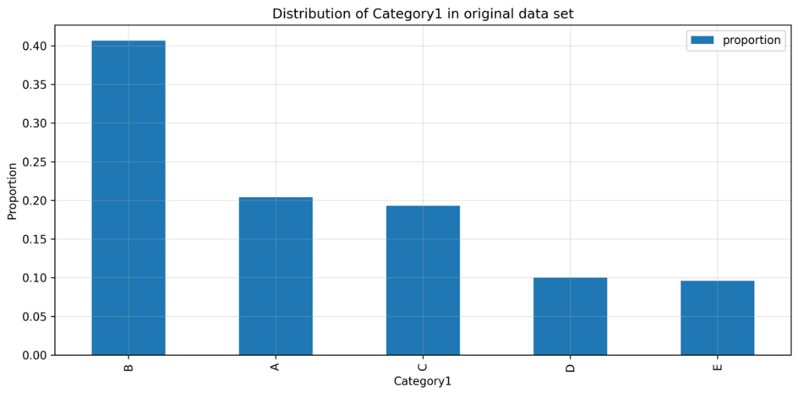

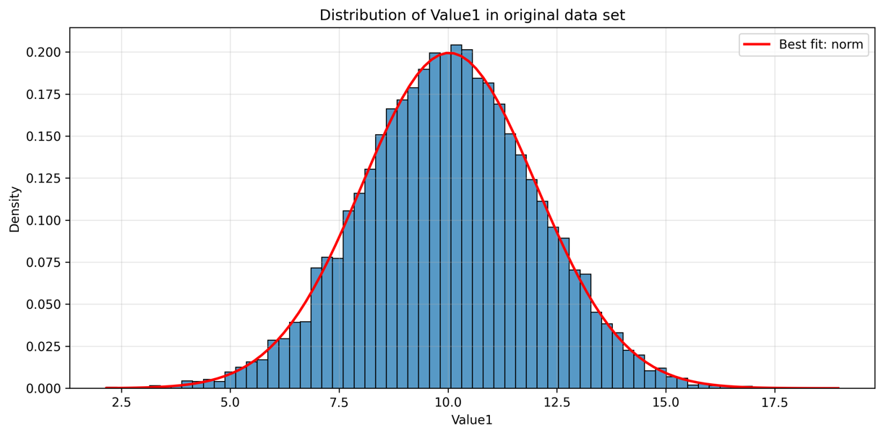🔍 **Statistical Comparison Between Original and Sample Data**

🔹 Analyzing Category1...

- Chi-Square Test: Statistic=5.4280, p-value=0.2461

(p > 0.05 indicates proportions match)

🔹 Analyzing Value1...

- KS Test: Statistic=0.0075, p-value=0.9412

(Values closer to 0 and p > 0.05 indicate good match)

🔹 Analyzing Value2...

- KS Test: Statistic=0.0067, p-value=0.9783

(Values closer to 0 and p > 0.05 indicate good match)

📊 **Visual Comparison Between Original and Sample Data**

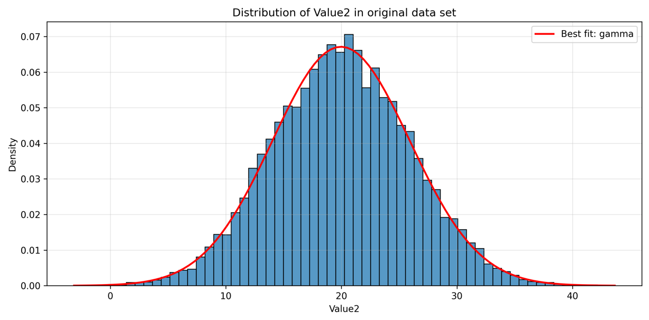📌 **Justification for Sample Dataset Alignment**

**6.2 Sample Data Set**

**6.2 .1 Categorical Column: Category1**

Sample proportions:

Category1

A 0.2095

B 0.4124

C 0.1868

D 0.0980

E 0.0933

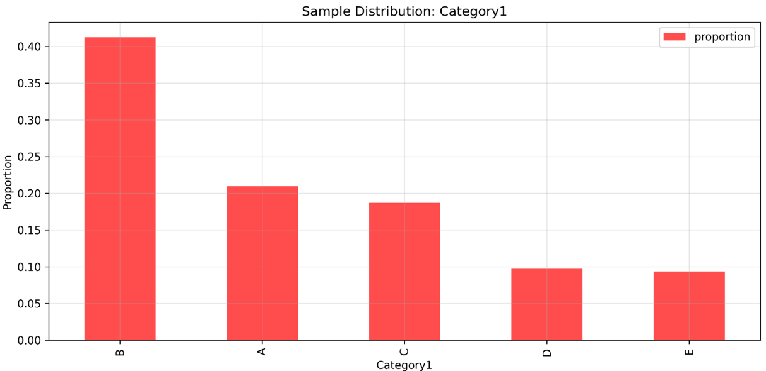

**6.2 .2 Numerical Column: Value1**

Distribution: Normal

- Sample mean: 10.05

- Sample std: 2.00

- Sample skew: -0.02

- Sample kurtosis: 0.06

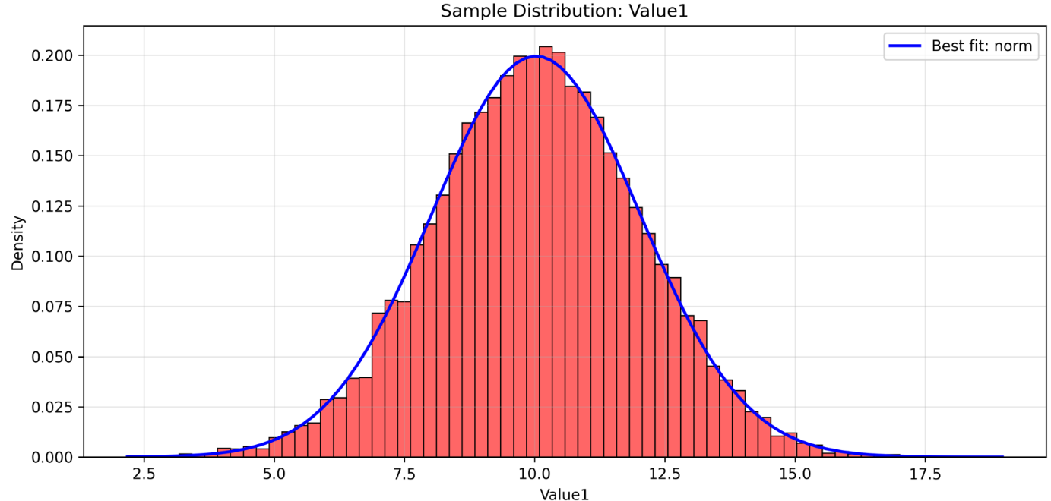

**6.2 .3 Numerical Column: Value2**

Distribution: Gamma

- Sample mean: 19.97

- Sample std: 5.97

- Sample skew: 0.02

- Sample kurtosis: 0.01

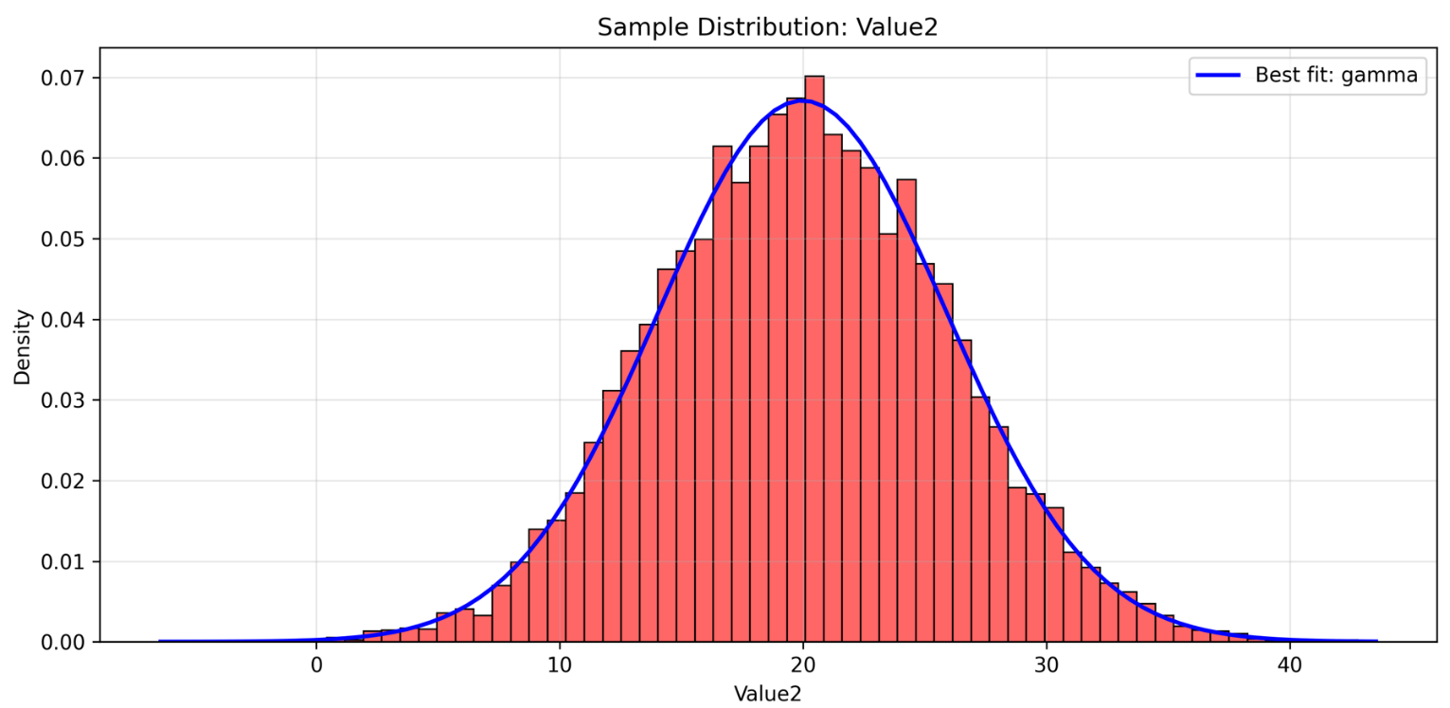

**7. Comparison of Original vs Sample data distributions**

**7.1 Categorical Variable**

|  |  |
| --- | --- |
| Original Category1 variable | Sample Category1 variable |
| A 0.2043 | A 0.2095 |
| B 0.4065 | B 0.4124 |
| C 0.1930 | C 0.1868 |
| D 0.1001 | D 0.0980 |
| E 0.0961 | E 0.0933 |
| **Chi-Square Test: Statistic=5.4280, p-value=0.2461**  **(p > 0.05 indicates proportions match)** | |

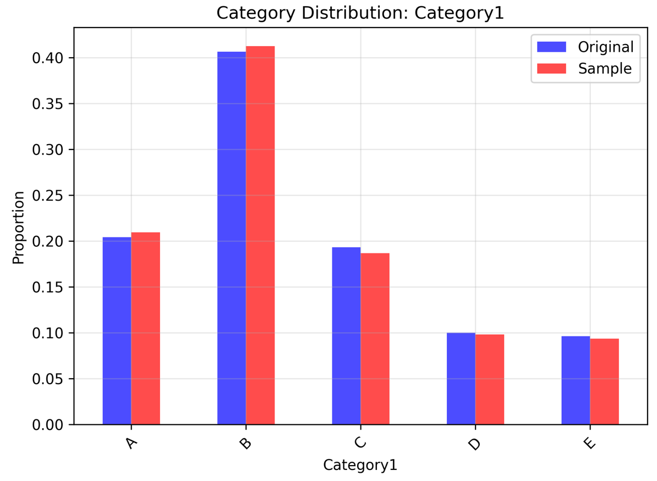

**7.2 Numerical Variable – Variable 1**

|  |  |
| --- | --- |
| Original Value1 variable | Sample Value1 variable |
| mean: 10.02 | mean: 10.05 |
| std: 2.00 | std: 2.00 |
| skew: -0.02 | skew: -0.02 |
| kurtosis: 0.06 | kurtosis: 0.06 |
| **KS Test: Statistic=0.0075, p-value=0.9412**  **(Values closer to 0 and p > 0.05 indicate good match)** | |

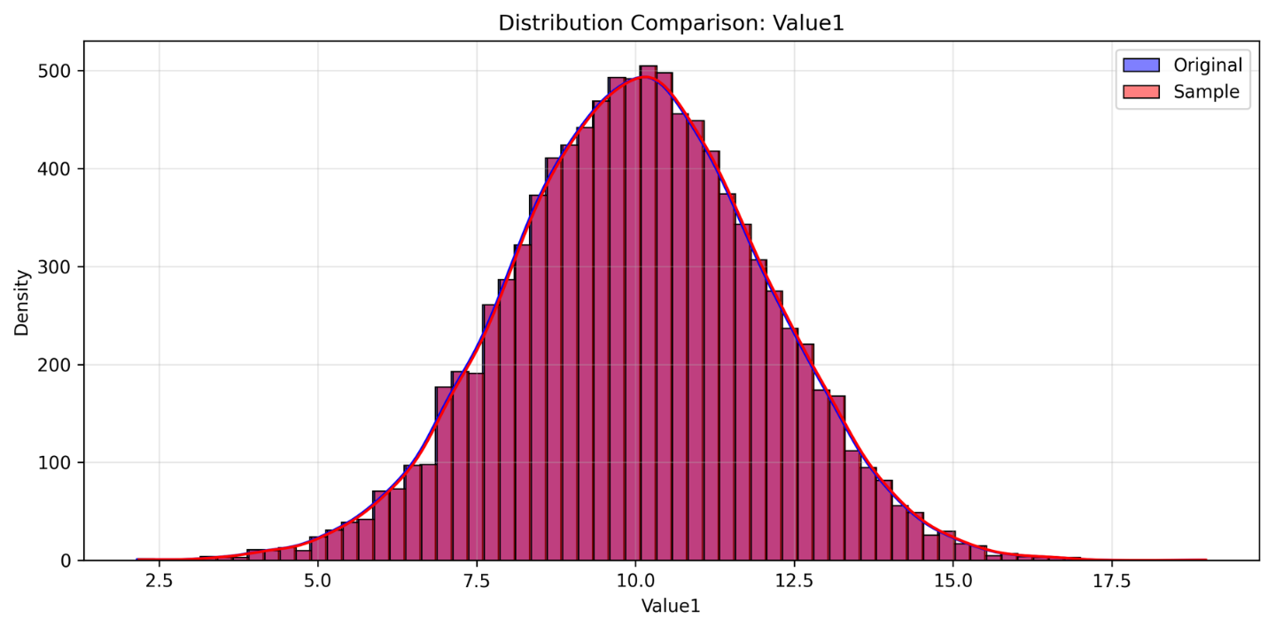

**7.3 Numerical Variable – Variable 2**

|  |  |
| --- | --- |
| Original Value2 variable | Sample Value2 variable |
| mean: 19.99 | mean: 19.97 |
| std: 5.94 | std: 5.97 |
| skew: 0.01 | skew: 0.02 |
| kurtosis: -0.05 | kurtosis: 0.01 |
| **KS Test: Statistic=0.0067, p-value=0.9783**  **(Values closer to 0 and p > 0.05 indicate good match)** | |

